Lab Exercise
2
–

Terraform AWS Provider
Configuration

Batch
-

3

Exercise Steps:

Step 1: Create a New Directory:

Create a new directory for your Terraform configuration:

“
Terraform
-
Demo”

Step 2: Create Terraform Configuration File (main.tf):

Create a file named main.tf with the following content:

terraform {

required_providers {

aws = {

source = "hashicorp/aws"

version = "5.
30
.0
"

}

}

}

provider "aws" {

}

Name-Garvit janu
k

SAP ID- 500119646
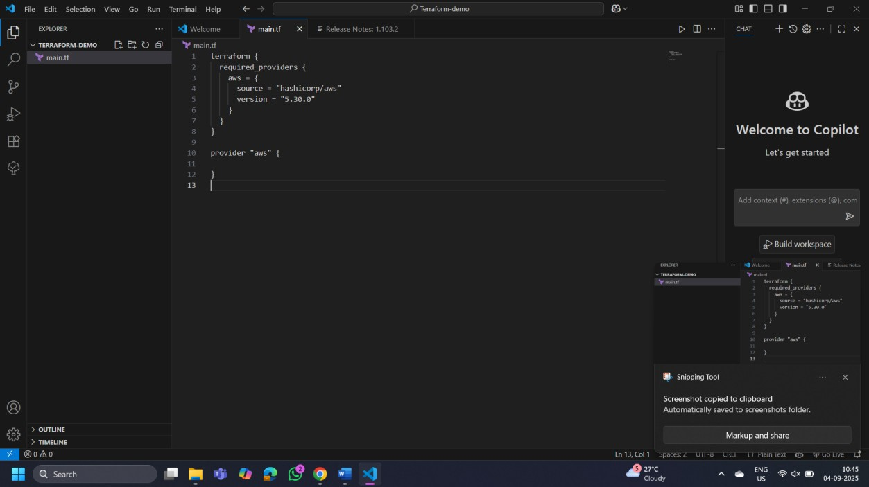
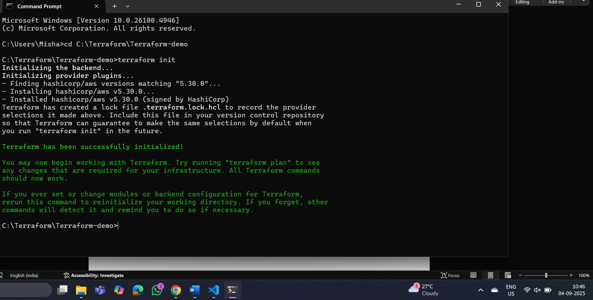

Step 3: Initialize Terraform:

Run the following command to initialize your Terraform working directory:

terraform init

